Tool Kit Outline*

- Scholarship information
  - Print off the scholarship for your future reference
  - Print off a list of sites or places you can find scholarships
    - Hint: Check them off when you go there
- Scholarship Tracker
  - A simple spreadsheet for tracking which scholarships you have applied to and every bit of information you might need to know about them
- Applications
  - Print off the actual applications. This can be helpful for future reference
- Scholarship Resume
  - List of talents, skills, volunteer experience, leadership experience, sports, clubs, etc..
  - Makes lots of copies
- Recommendation Letters
  - Recommendation letter request form
  - Copies of your recommendation letters
- Transcripts
  - Official Transcripts
  - Unofficial Transcripts
- Financial Documents
  - Tax Transcripts
  - Tax Returns
  - Parent or Guardian Tax Transcripts
  - Parent or Guardian Tax Returns
- Student Aid Report
- Essay Tips
  - Information and tips for writing the most successful essay
  - Copies of your essays
- Feedback
  - Ask for feedback and use it to improve your scholarship applications
  - Copies of feedback

When you are finished filling out the different forms, print everything off, start a scholarship binder and use this as an outline.

*Adapted from Carrol College's "Secrets to Winning Scholarships" binder.

Searching for Scholarships

Step 1. Check locally
Local scholarships might offer smaller rewards, but the number of applicants will most likely be smaller than national scholarships.

- School counselor or high school career center
- Local business scholarships
- Civic groups
- Community organizations
- Your employer
- Your parent’s employer
- Religious organizations
- Tribal Higher Education Packets

Step 2. Look into what your college/university has to offer
Many colleges and universities have scholarship funds specifically for students attending their school.

4-year MT colleges

- Carroll College
- Montana State University
- Montana State University Billings
- Montana State University Northern
- Montana Tech
- Rocky Mountain College
- Salish Kootenai College
- University of Montana
- University of Montana Western
- University of Providence

2-year MT colleges

- Aaniiih Nakoda College
- Bitterroot College
- Blackfeet Community College
- City College at MSU Billings
- Chief Dull Knife College
- Dawson Community College
- Flathead Valley Community College
- Fort peck Community College
- Gallatin College
- Great Falls College
- Helena College
- Little Big Horn College
- Miles Community College
- Missoula College
- Stone Child College

Step 3. Go online and find the scholarships that are right for you.
  - There are scholarships out there for everyone, just keep searching
  - Create a spam email. An email only used for scholarship search engines
  - Once a week check the scholarship search engines

Scholarship Search Engines

  - MUS search Engine
  - MCIS Scholarships
  - Fastweb.com
  - CollegeBoard.org
  - Scholarships.com
  - Montana Community Foundation
  - Mycollegeoptions.org
  - Collegegreenlight.com
  - Reachhighermontana.org

Organize your Scholarship application process *
- Write down each of the scholarships you are applying to.
- Make note of when they are due and when you submit your application.
  - Also check and see how they want you to submit the applications. Some require you to submit through an online application while others via post.
  - Hint: once you submit your application keep the mailing receipt or the confirmation page proving that you sent it in before the deadline.
- Write down the number of awards offered and the amount of the scholarship.
- Check to see what documentation is required.
  - On the scholarship tracker you can check the boxes coinciding with the required documents. This will be helpful as you put your application together and make sure you have everything.
- Prioritize the scholarships.
  - With everything written down you can make note of which scholarships you want to work on first. You might want to focus on the scholarships that have an earlier deadline, scholarships that have multiple winners compared to just one, or work on the smaller scholarships first to get comfortable with the application process.

* Scholarship Tracker form

Organize your scholarship awards*

- Keep track of the scholarships you are awarded as there might be requirements in order to receive the award.
- Knowing the amount of each award you are receiving will help you as you calculate your financial need and as you look at possible loan acceptance.
- Always keep track of the contact information provided for the scholarship in case you have to renew your scholarship, or just need to ask a question regarding the scholarship.
- While some scholarships offer one-time awards, some scholarships have specific requirements in order to retain the award. Other scholarships you must renew annually. Make sure to write down any requirements in order to continue receiving that award.
- Remember to send a thank you letter. You can find several examples of thank you letters online.

*Scholarship Award Tracker Form

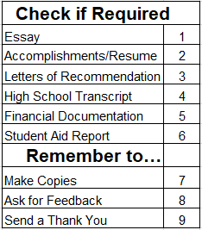
Scholarship Tracker
*Use this tool to help you keep track of the scholarships you want to apply for

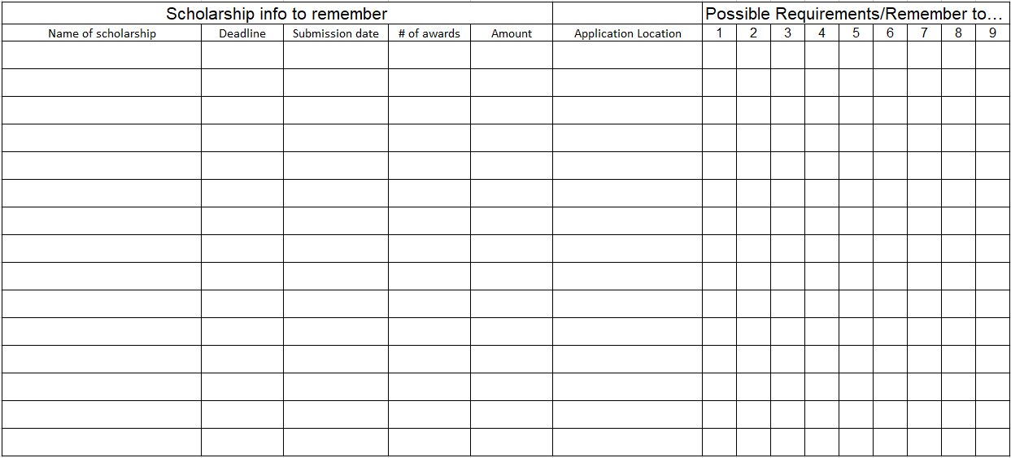

Scholarship Award Tracker
*keep track of the requirements so you don't lose your award

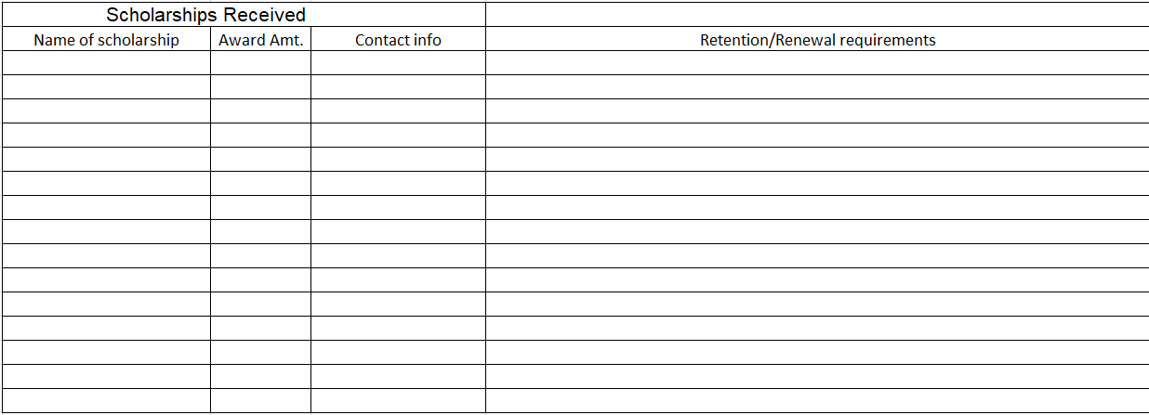

Scholarship Resume
Activities completed throughout high school
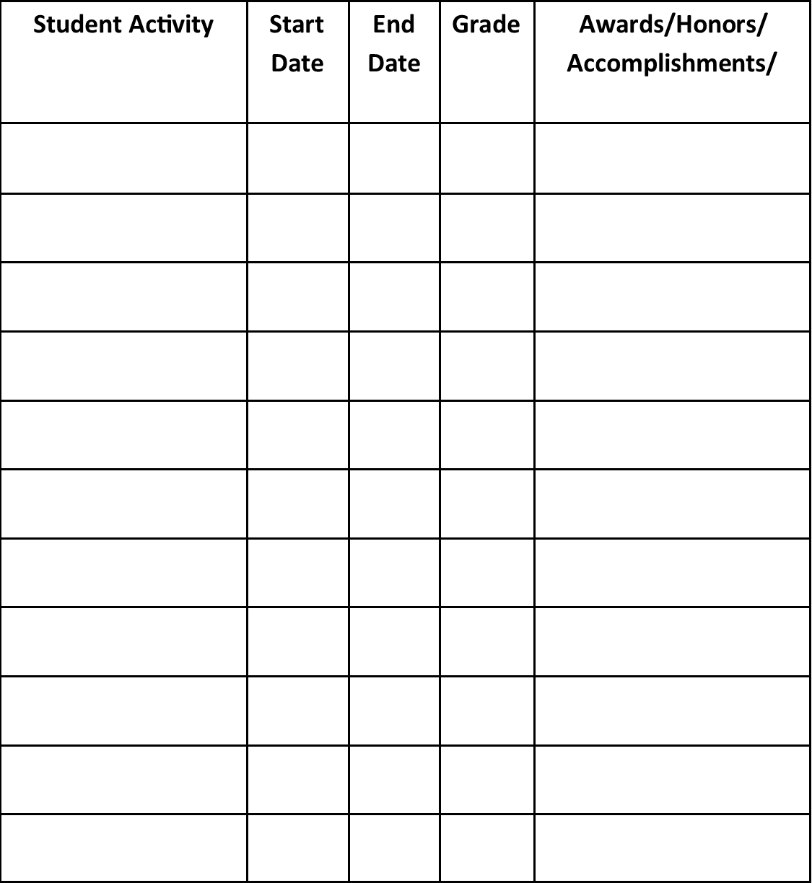

Tips for Letters of Recommendation

  - Choose people who know you well. The more personal and detailed the letter, provides the scholarship judges with a stronger impression of who you are. Some scholarship will ask for an academic letter of recommendation and/or a community letter of recommendation. Look to high school teachers, coaches, work/volunteer supervisors, or pastors/ ministers who you know and respect.
  - Ask early. Leave plenty of time between asking for a letter of recommendation and the scholarship deadline. Provide whoever you ask at least 3 weeks to write the letter and ask for them to give you the letter at least a week before the scholarship deadline.
  - Involve them in the application process. The people you ask might have some great feedback for you throughout the application process. With their knowledge of you, they should be able to help you apply for scholarships that are best for you and guide you through the application process. If you involve them in the process they will also be able to make their recommendation letter more specific to your needs.
  - Provide copies of some of the application material. Give them a clearer picture of the scholarship and how you are trying to obtain it. Send them copies of the scholarship, your essay, resume and accomplishments, and your transcripts. Doing this will help them be involved in the application process and how they should word their letter. Also, they might provide feedback on your essay if you ask.
  - Show appreciation. Once you send in the application, send a thank you card expressing appreciation for their support. Through this you are building a positive relationship which could help you in the future when you need another letter of recommendation.

Request for Letter of Recommendation

Name:
Date:
Current GPA:

Scholarship: Academic area/s of interest: Please complete letter by:

Personal characteristics and highlights based on scholarship criteria:

History of relationship:

Reasons for applying to this scholarship:

Scholarship application attached: Yes No Scholarship Resume attached: Yes No

Writing a Successful Scholarship Essay

Start Early
In order to make sure your scholarship is successful you need to have plenty of time before the submission deadline. Whether you are following the tips provided here or tips you find online, the process will take a while. There is not a definite time frame but don’t wait until the week before the deadline to start your essay.

Understand the Essay Question
Read through the essay question and make sure you are understanding what is being asked. One way to understand the question is understand who is asking the question. Many scholarships are provided by organizations or foundations that want their recipients to reflect similar values to them and the purpose of the award. Get to know more about the Scholarship and who is offering it and it will help you understand the question more. If you still don’t understand the question, ask someone for their thoughts.

Focus on the Introduction
When you consider how many essays the scholarship committee reads, it will be smart to focus on an introduction that grabs their attention. Start your essay off strong by being creative. Try to think outside the box and you will stand out amongst all the other essays. Entertain your readers with a short personal story, hook them with intriguing facts, but don’t begin the essay simply answering the question.

Be Personal
This is where you are different from everyone else who is applying for scholarship. You have your own stories, and your own personality. Stand out by showing the judges or committee who you are, what you believe, and what/who has made you the person you are today. As an example, if the essay question asks you why you want to work in the health science field, tell the story of you taking care of your sister after she sprained her ankle, the multiple surgeries and countless hours in physical therapy, or your love for going to the doctor as a child.

Get Feedback
Have as many people as you can proofread your essay. This is important so that you catch every grammar error or mistake. Judges are looking for essays that are worth their time. If they find a grammar error, it will be thrown out. Ask your proofreaders to look for grammar errors, to check that you are answering the question/staying on topic, and to help you get rid of extra sentences or words that are unnecessary.

